Procedure for Download of File Merge Utility (in case file is split) and merging of Split BIN files
- Procedure for Download and installing “File Merging Utility (FMU)”
- Download “File Merge Utility” from TIN website (www.tin-nsdl.com ) under the option “Form 24G” in “Download section”. FMU can be downloaded at the desired location. For example, desktop (see Fig 1.1 below).
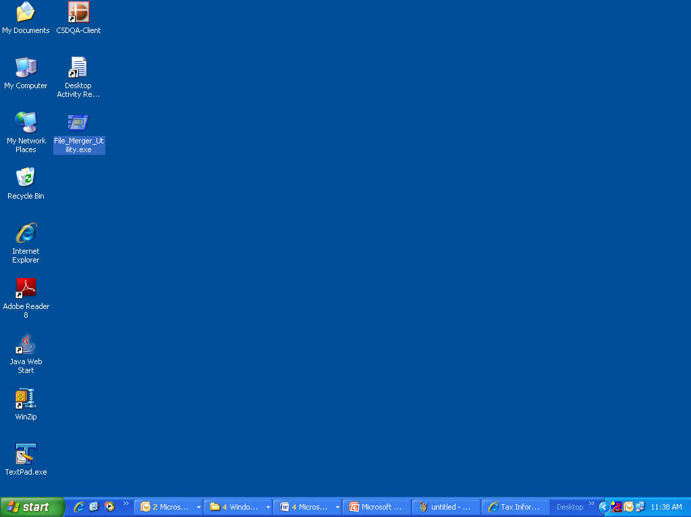
Fig. 1.1
- JRE (Java Run-time Environment) [versions: SUN JRE: 1.4.2_02 or 1.4.2_03 or 1.4.2_04 or IBM JRE: 1.4.1.0] should be installed on the computer where the e-TDS/TCS FVU is being installed.
- JRE is freely downloadable from http://java.sun.com or http://www.ibm.com/developerworks/java/jdk or
You may ask your computer vendor (hardware) to install the same for you.
- For installing the File Merge Utility, double click on the exe (File_Merger_Utility.exe) file downloaded from the TIN website.
- On double clicking, a window will be displayed for extracting the contents of the exe file. Default location for extracting the files will be C drive (see Fig 1.2 below).
- The files can also be extracted in any other location (other than C drive). In that case, define the appropriate path by clicking the ‘Browse’ button where the files are to be extracted.
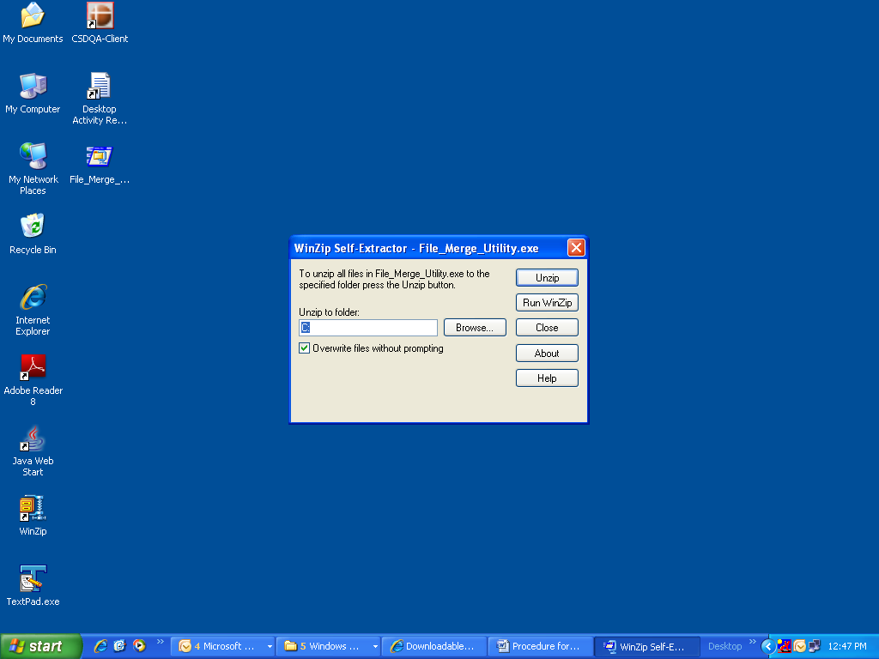
Fig. 1.2
- For extracting the contents of the file click “Unzip” button. On clicking the “Unzip” button, two files as below (see Fig 1.3 and 1.4 below) will be extracted at the default path (C:\File_MERGE_UTILITY) or the desired location as the case may be:
  - File_Merging_Utility.jar
  - FMU.bat

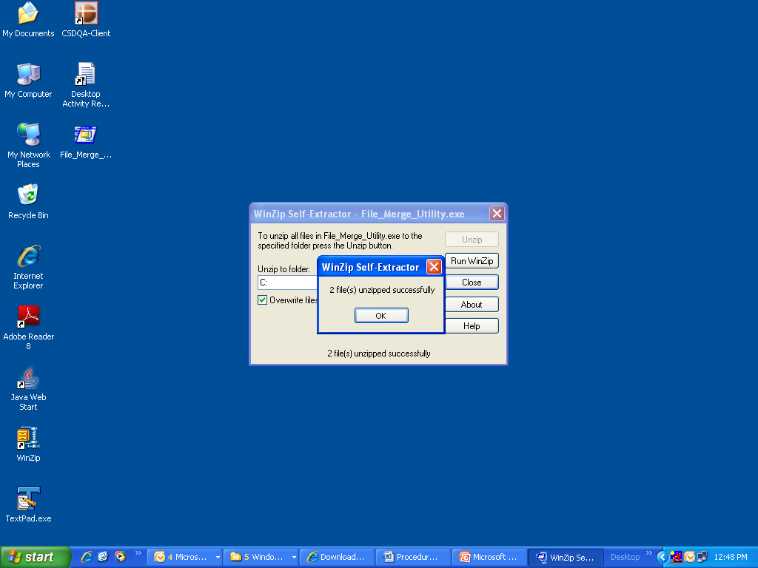
Fig. 1.3
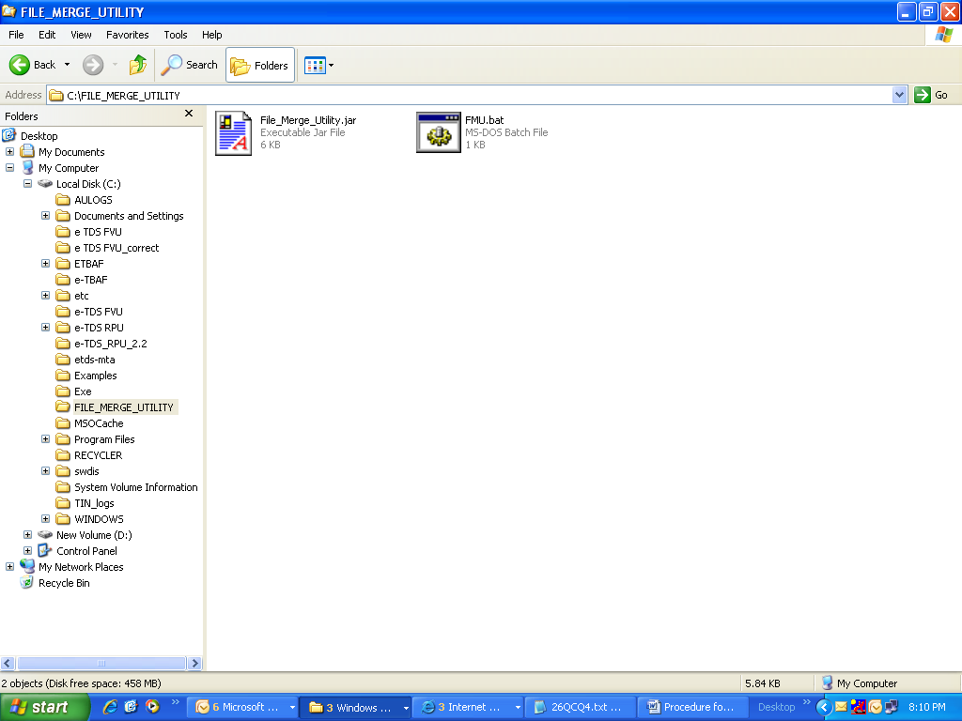
Fig 1.4
- To open the File Merge Utility, double click on the file “FMU.bat” available in the folder where FMU has been installed. On double click of the file, window as below will open (Fig 1.5 below).
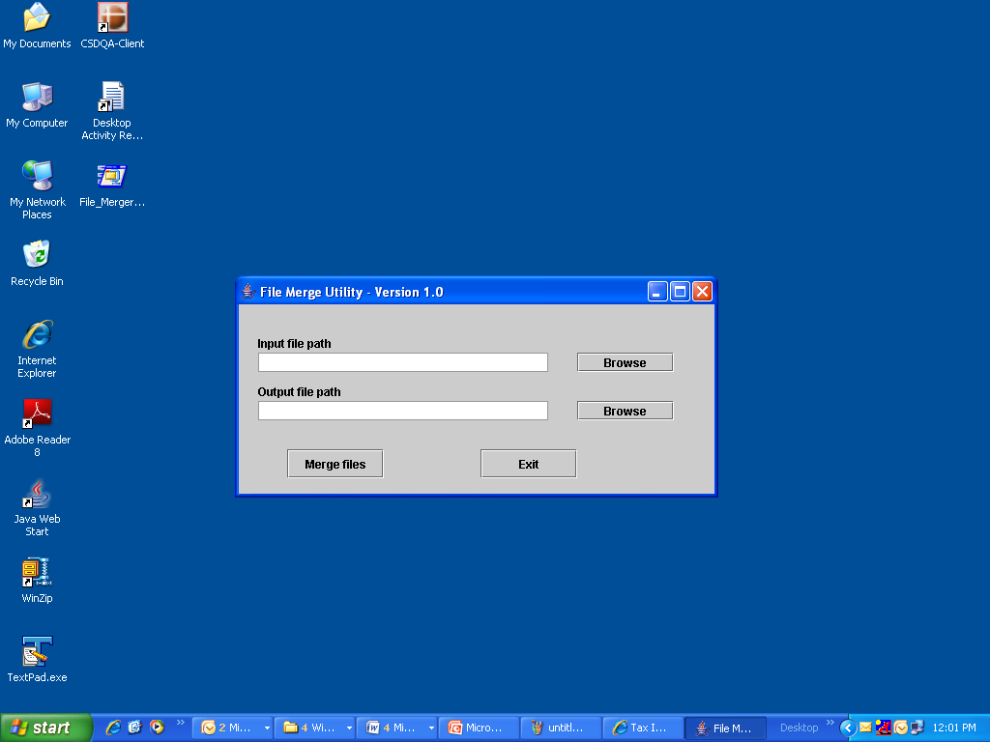
Fig. 1.5
- Procedure for merging the split BIN files.
- Copy all the split files in the single folder at the desired location.
- Open the “File Merge utility” by double clicking the file “FMU.bat”.
- Click on “Browse” button of “Input file path” and provide path or navigate to path of the folder where all split files are copied (see Fig 1.6 below). Example: files are copied at D drive and the folder name is Form24 G BIN
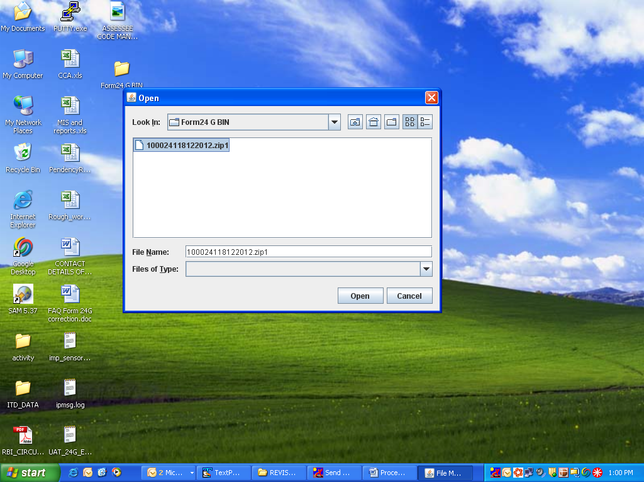
Fig. 1.6
- On navigating to the folder where all the split files are copied, only one file i.e., the first file will be visible (see Fig 1.6 above). Example 100024118122012.zip1
- Select the visible file and click on button “Open” (see fig 1.6 above). Example: files are copied at path D:\ Form24 G BIN and the input file name is 100024118122012.zip1
- Click on “Browse” button of “Output file path” and provide path or navigate to path of the folder where merged consolidated BIN file is to be created (see Fig 1.7 below). Example: the output file path is D:\Form 24G BIN.
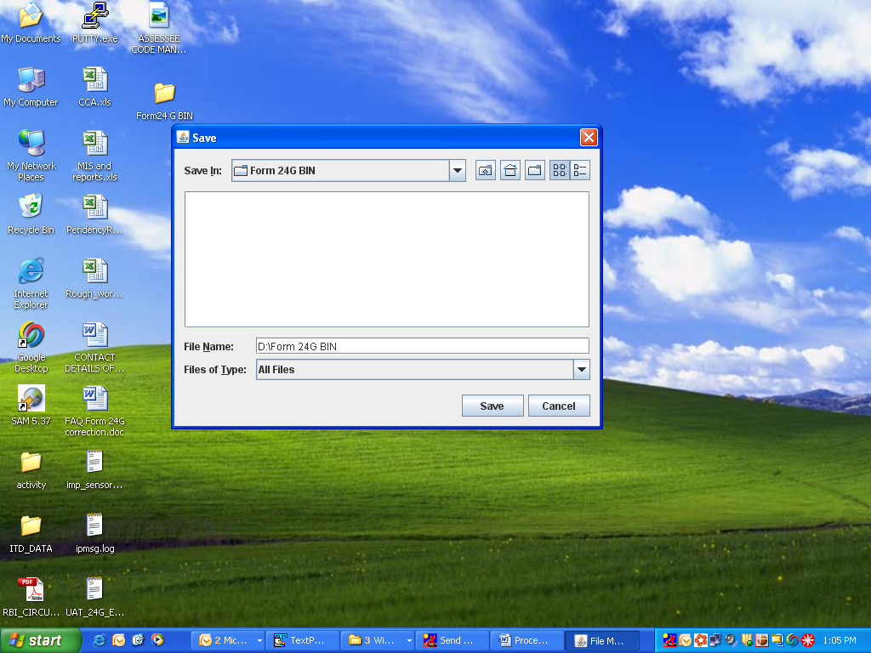
Fig 1.7
- On selecting the location for saving the merged file, click on “Save” button (see Fig 1.7 above).
- Click on “Merge files” button available on the File Merge Utility window.
- On successful merging of split files message “File merged successfully at xxxxxxxxxxx (desired location)” will be provided (see Fig 1.8 below)and a merged file in compressed form will be created at the output path. Example the output file path is D:\ Form 24G BIN and the file name is 100024118122012.zip
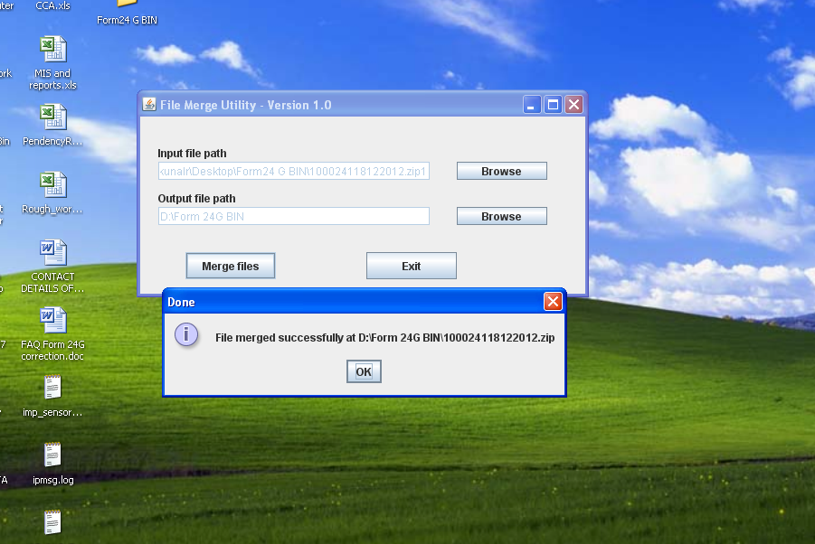
Fig 1.8
- Merged file created is password protected.
- For extracting the contents of the merged file follow the procedure as provided in the e-mail
- In case of any assistance contact TIN call centre at 020-27218080.

