Steps to download and install Form 24G File Validation Utility

- Form 24G File Validation Utility (FVU) can be downloaded from TIN website at the following locations:

  - Services→Form 24G → Form 24G FVU.exe (version 1.2)
  - Downloads → Form 24G → Form 24G FVU.exe (version 1.2)

- On download, file with name “Form24GFVU.exe” will be saved at the desired location.

- For installing the Form 24G FVU, double click on the file downloaded (Form 24GFVU.exe) from the TIN website.

- On double clicking, a window will be displayed for extracting the contents of the exe file. Default location for extracting the files will be C drive (see Figure 1.1 below).

- Files can also be extracted in any other location (other than C drive). In that case, define the appropriate path by clicking the ‘Browse’ button where the files are to be extracted.

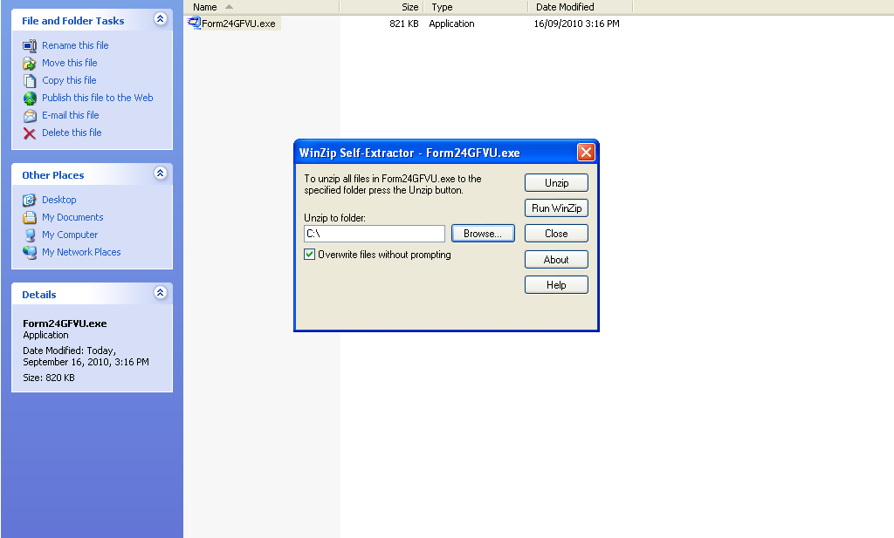
Figure 1.1

- Click on “Unzip” to extract the Form 24G FVU.

- On clicking the “Unzip” button two files are extracted at the default path (C:\Form 24GFVU) or the desired location, as mentioned below created as below in Figure 1.2:

  - Form 24GFVU.jar
  - Form 24GFVU.bat

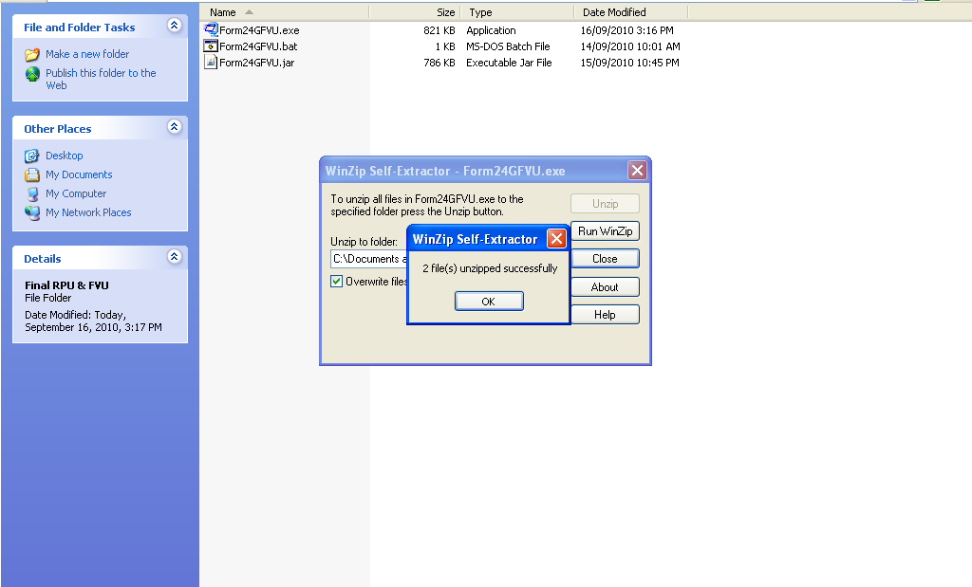
Figure 1.2

- To open the Form 24G FVU, double click on the file “Form 24GFVU.bat” available in the folder where FVU has been installed and the FVU will open as in Figure 1.3 below.

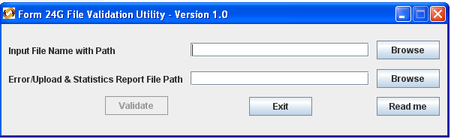
Figure 1.3

